Darren DeLaurentis

SDEV140

October 13, 2022

**“Tricky Trivia!” Game User Guide**

Hello and welcome to the user guide for Tricky Trivia! This guide will help walk you through the correct steps to operate the game and ensure the highest amount of user enjoyment. To get started see below.

1. **Start-up**
   1. The game can be accessed via the following GitHub link: <https://github.com/Blitzfire87/SDEV140->
   2. Once you have accessed the file, open the file using the appropriate IDE program.
2. **Running the game**
   1. The game can begin by pressing the F5 key on your keyboard
3. **How to play**
   1. In the first window, the screen will look like this: 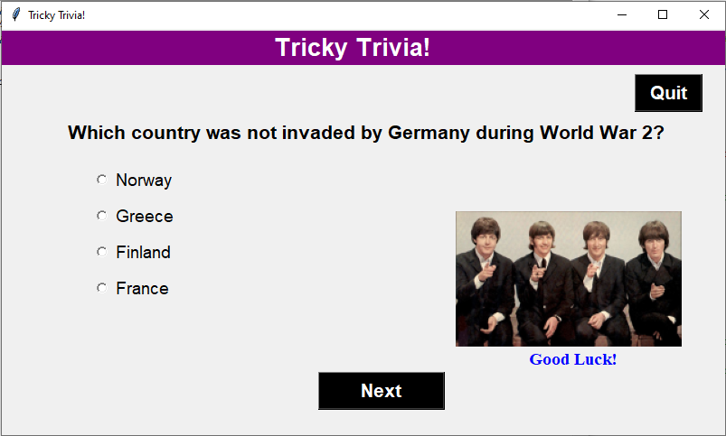
   2. Displayed is a question and four answer options
      1. Use the radio buttons to select you answer

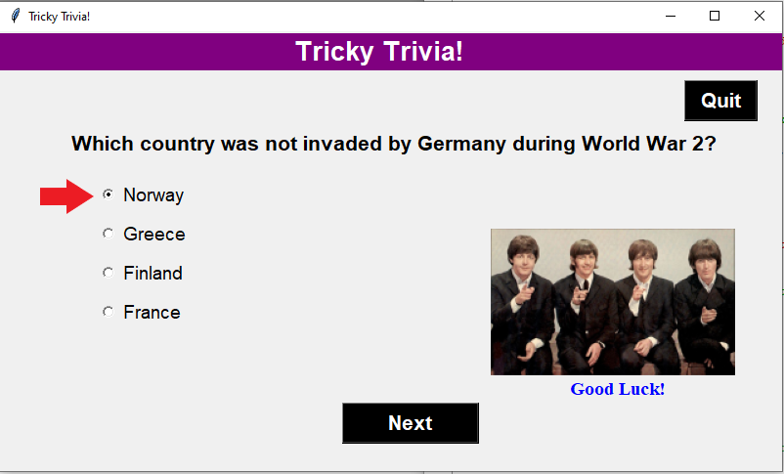

* + 1. Click the “Next” button to move on to the next question.

Note: If you click next without selecting an answer, the question will automatically be marked wrong.

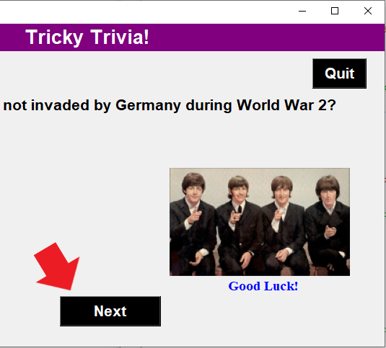

* + 1. If at any time you would like to quit the game, click the “Quit” button

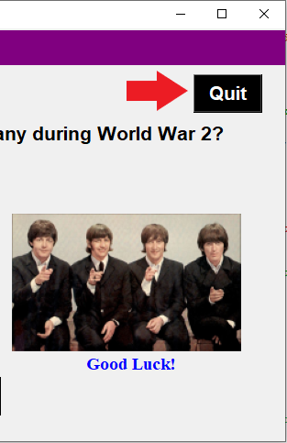

1. **The “Results” Window**
   1. Once you have answered the final question, a second window will pop up displaying the results

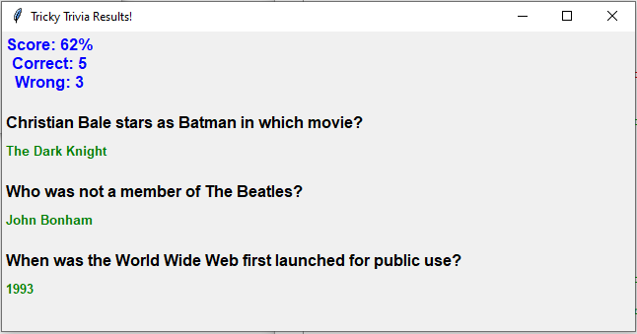

* 1. At the top in blue is your score containing: the percentage grade you received, the number of questions answered correctly, and the number of questions answered incorrectly.
  2. The questions answered incorrectly are displayed at the bottom with the correct answer.